Record No: 0613
WILLIAM BELLINGHAM SOMERVILLE

Only son of Corry Somerville (0586) and Lucinda Simonton (0587).

Birth: 28 Apr 1839 in New York
Baptism: 1 March 1844 St Paul’s Episcopal Church, Rochester, New York.
Marriage: 1 Aug 1868 Amanthus Buckner, widow of Leander Buckner. She was nee Shipp, born 8 December 1825,
Louisville, Kentucky, daughter of Ewell Shipp by his wife Evelyn
(Evalina)Bray. She was 14 years older than William, and had 3 young sons, 2 of whom were surviving at her marriage to William. She died 26 October 1906
In the files of WMStevenson, there is a handwritten poem by William, which is quite poignant. It speaks of unrequited love, and I wonder if it was a love prior to his meeting Amanthus. Who was she, I wonder?

Poem written by William Bellingham Somerville
If thou hadst never smiled on me,
Or fondness for me shown
Despair’s dark shadow would not now
Around my heart be thrown.
The hopes I cherished in my heart
Through the few Sunny years
Have perished: have been washed away
By many bitter tears.
Yet still my heart in secret shall
With fond affection beat
Although we never never more
Again in love can meet.
So fare thee well, Oh how I wish
That I had ne’er thee seen
For you and I shall never be
The same as we have been.

Death: 24 April 1897 in New York; buried 28 April 1897 in same grave as his father
Woodland Cemetery, Cleveland, Ohio. Cause of death was Chronic Intersticial Nephritis and Chronic Cystitis.

Notes:
SR3019 Letter from his father regarding his birth
Letter from Walter A Hill refers to his death is New York.

Source: Somerville Index.
Article in The Western Union Press, copied by family member
Obituary from New York Daily Tribune, Monday, 26 April 1897
The Electric Engineer, Vol. 23, New York, 1897
https://books.google.ca/books?redir_esc=y&id=qehQAAAAYAAJ&q=Somerville#v=snippet&q=Somerville&f=false
The Military Telegraph during the Civil War with the United States. William R. Plum, 1882.
The Telegraph in America. James D. Reid. Amo Press. 1879
The Fourth Estate, a Newspaper for the Makers of Newspapers, Vol. IV, No. 93, New York. December 5, 1893. https://books.google.com/books/about/Fourth_Estate.html?id=3WhCAQAAMAAJ

NOTES re William B Somerville

Census 1870, August 10. he lived in the 11th Ward of Louisville, Kentucky, and was an express agent. His wife was 'at home', and it states that she was born in Louisiana. Her property was valued At $10000.
1878 N.Y. City Directory shows William as an ‘agent’, and living at 21 Fifth Avenue.
1888 N.Y. City Directory indicates that William was Superintendent (of the Associated Press).
1889 N.Y. City Directory shows him as living in ‘The Madison’. Clearly the name of the building was sufficient enough address.

William had a desire to visit the land of his father’s birth, and he travelled there, and visited family in 1889, Geronimo.
Corry wrote to his brother Tenison and described William as: the ditto of yourself, fair and blue eyes, a big good natured fellow - smart withal

Professional and Personal Career of William Bellingham Somerville

All references to William Bellingham Somerville refer to him in a positive and admirable light. He was handsome, he was clever, he was kind, understanding and generous. William was respected by employees and superiors. His ability and skill were recognized during his career in the Union Army, and in private employment through the future Western Union Telegraph Company and the American Associated Press. It is unclear as to how much formal education William received, but his intellect must have been high. He certainly had an interest in the arts, given his membership in the Lotos Club, and was a gifted writer himself. He appears to be a kind and gentle soul.

- Copied from The Western Union Press by family member

William B. Somerville
“We publish today a portrait of Mr. William B. Somerville, the newly appointed Superintendent of the Press Transmission Department of the Western Union Telegraph Company. Mr. Somerville learned the art of telegraphy in 1857, and acted as an operator in Buffalo. He entered upon the service of military telegraphy during the first year of the war, and was attached to General Rosecrans’ staff as cipher operator at Corinth, Miss. After the capture of Memphis, he was sent by General Grant with a detail of two companies to open the telegraph lines from Grand Junction, Tenn., to Memphis, a distance of fifty miles, which task he accomplished in four days, putting the lines in working order. Mr. Somerville remained at Memphis one year, and was then assigned to duty at Nashville as cipher operator on General McPherson’s staff, and accompanied that gallant commander during his Georgia campaign, being on the staff when the General was killed. Subsequently, Mr. Somerville was detailed for duty as Assistant Military Superintendent of Telegraph lines in Tennessee and Northern Alabama. He remained in this position about one year and was then appointed Military Superintendent of Telegraph Lines, and in that capacity built the line through to Grenada, Miss. He continued in Memphis until the military lines were turned over to the Southwestern Telegraph Company, of which Dr. Norvin Green was President. Mr. Somerville then went to Louisville as cipher operator for General George H. Thomas, and also served the Western Union Company in that city, continuing in their employment for nearly five years, when in 1870, he entered the service of the American Press Association as agent at Louisville. After a few months he was transferred to Cincinnati, a more important post, where he stayed two years, during which time he ? the ? convention; and as a result of his success in distancing the other associations he was induced to come to New York as General Manager of the American Press Association. At that time the Association was nearly $14,000 in debt with a current deficit of $200 a week. Mr. Somerville took the matter in hand with wisdom and vigor. He affected a prompt and complete reorganization, more than doubling the telegraphic news reports to the papers served by the association, and in less than two years the association was wholly paid off and was realizing a profit of $150 per week.
Subsequently, on account of the mutual strife among the stock-holders, growing out of the efforts of one man to obtain control, The Daily Graphic, and other leading journals were compelled to abandon the organization and form the National Association Press which under the efficient administration of Mr. Somerville became one of the strongest and most successful news gathering organizations ever founded. It is entirely out of debt and the extent of its business may be conjectured from the fact that its payments for telegraphic transmission alone amounts to nearly $100,000 per annum. By his acceptance of the position of superintendent of the Press Transmission Department of the Western Union, Mr. Somerville increases the facilities at his command for promoting the interests of the entire press of the country. Among the special qualifications possessed by Mr. Somerville for the discharge of the arduous and intricate duties of his present position is his happy faculty of harmonizing interests that under other and less skillful hands might be antagonistic.
It may be of interest to Mr. Somerville’s many friends to know a fact which his own modesty leads him to avoid mentioning, viz. that in consequence of the recent death of his father, he is next in line to the title of Lord Athlumney. Lord Athlumney was first Sir William Somerville, when he was Secretary of Ireland. The title is at present held by a son of Sir William who is childless, leaving but one life between the title and the subject of this sketch. There are three estates, the Somerville, the Athlumney and the Merydith, held by the present lord, all of which, of course, go with the title.
Mr. Somerville’s grandfather was a major in the British Army and was killed at the storming of Badajos. The family goes back to the year 1100 and many of its members were soldiers distinguished for their gallantry and skill in warfare.”
- Found in The Electric Engineer, Vol. 23, New York, 1897
In the same volume, March 17, 1897 there is a statement that W.B. Somerville had been dangerously ill, but thankfully is now recovered and convalescing.

W. B. Somerville,

”William B Somerville, superintendent of the press service of the Western Union Telegraph Company, died in this city on April 24th. He was born in Toronto fifty-seven years ago. He came to this country at an early age and thirty years ago entered the employ of the Western Union, in which he gradually rose to the responsible place he held at his death. He was greatly respected by the employees and officers of the company, and his death is sincerely regretted. Mr. Somerville served during the war, and soon after its close married, his wife’s former name having been Mrs. Buckner. He leaves no children, but, besides Mrs. Somerville, several step-children and two sisters survive him. He had been ill about sixteen weeks, bladder trouble, which made necessary an operation, performed a week ago, being the cause of death. The burial took place at Cleveland, where his father, mother and three sisters are buried, and where one of his surviving sisters lives.
Through his connections with the Western Union Telegraph Company, Col. Somerville became personally acquainted with many public men, and it was his boast that he had missed no national political convention since 1869. He was one of the leading military telegraph operators during the war.
In 1876 it was Col. Somerville who handled all the telegrams in this city on the election of President Hayes, and as all of the dispatches were signed Somerville, he had the crowds reading bulletins wondering who Somerville was. He was a member of the Lotos Club.”

- Article in The Fourth Estate, a Newspaper for the Makers of Newspapers, Vol. IV, No. 93, New York. December 5, 1893.
This article contains a portrait of William B Somerville, as well as an article entitled “Popular Veteran”.

- From The Telegraph in America. James D. Reid. Amo Press. 1879
Regarding a thwarted strike in July 1870, by pressworkers:

“It is easy to see that under such disturbed conditions, much patience and skill had been needed in the direction of affairs. This was especially true respecting the supply of Press matter, the usual volume of which had come to be very large, and to a vast army of papers in every State in the Union. In this
latter field there was no name so conspicuous as that of Mr. Somerville, the W. Union Company's Press Superintendent. For nearly five weeks his work was exhausting, and he became, by a kind of natural selection, the mouthpiece of the Company to the public. It is only doing justice to a faithful and capable man to say that the Press service throughout was a triumph of fidelity, and although he failed to prevent much false information from being uttered by papers always hostile, and which misled many good men to their injury, he had the satisfaction of the unanimous acknowledgment of the vigor and correctness with which the service of the Press had been maintained.” (p. 706)

and further:

“Approaching room 33, on this floor, may be seen a very earnest gentleman, with a step so long that he seems to be taking the dimensions of waste spaces along the tessellated floor. That is William Bellingham Somerville, well known as Press Manager. He is returning from a consultation over the tariff of rates to be charged the Arizona Daily Tombstone and the Montana Weekly Screw, and his brow is serious and his step grave. Mr. Somerville is of Huguenot descent, born in Toronto, Ontario, April 28th, 1840, and in the very prime of life. He was educated in Rochester, N. Y., learned the art telegraphic at Welland, Ontario, and served as operator at Port Colborne, Brantford, Stratford and Buffalo, in the offices of the Buffalo and Lake Huron Railroad Co.On the opening of the war, Mr. Somerville offered his services to the U. S. government at St. Louis, and was ordered to report for duty at Pittsburgh
Landing. Soon afterwards he was placed at the headquarters of Gen. Halleck, at Brittan House, Tennessee. In 1863 he was appointed confidential cypher operator at Rienzi, Miss., under Gen. Asboth, and afterwards served under Gen.Rosecrans, in the battle of Corinth. In Gen. Grant's preliminary movements on Vicksburg, Mr. Somerville built the military line from La Grange to Memphis, and took charge of the latter station. At a later date he served under Col. Van Duzer, at Nashville, in special charge of the lines to Chattanooga, and afterwards became a member of the staff of Gen. McPherson, serving that gallant officer until his death. Toward the close of the war he was summoned to Louisville, Ky., as government cypher operator under Gen. Thomas. In 1870 Mr. Somerville became agent of the American Press Association at Louisville, Ky., and River editor of the Commercial Advertiser. In 1871 he reported with great success, and in advance of all competitors, the Greeley Convention at Cincinnati, O., which led to his speedy appointment to the General Managership of the American Press Association at New York. This post he held until 1879, when he entered the service of the Western Union Telegraph Company as General Press Manager, the post he now fills, and for which his
natural affability, wide acquaintance with the personnelle and wants of the Press peculiarly fit him.” (p.724)

“The administration of Mr. Somerville is worthy of a more detailed record than can be given here. There were serious obstacles to any uniform success during the period of his management. He had to make his arrangements largely, and almost wholly, through what were generally spoken of as opposition
telegraph companies, the status of which was uncertain and changeable, and on account of which no definite and lengthened contracts could be reliably made, so that all arrangements entered into being of a more or less temporary character, were, of course, a constant source of anxiety and watchfulness to the manager. The comparatively limited area of the connections of the opposition lines was also a source of perplexity. It rendered necessary the use of several company's wires to reach desired fields of communication. Yet by an intimate knowledge of the business, the outgrowth of long newspaper service, and himself being also a practical and skilled telegrapher, Mr. Somerville performed with patience, skill and success, during a lengthened period, a very laborious and difficult service to the press. When Mr. Somerville assumed the active management of the American Press Association, it had already spent all its capital and was largely in debt. Nothing kept it together but the influence of its worthy President, Francis Wells, of the Philadelphia Bulletin, who devoted much of his time, and traveled at his own expense, to make it a success. Mr. Somerville was only induced to undertake the task of resuscitation by the promise of Mr. Wells' support, and to whom he laid out his plans. These were at once approved. In a year the debt was removed. By liberal arrangements effected with the telegraph companies, by which they were made collectors and • partners in the assessments made, the Association became profitable and prosperous, until parties bought out the control and changed its methods to such an extent that the leading members of the Association withdrew and formed the National Associated Press, already referred to. To Mr. Somerville this long and difficult service was of immense value, and educated him by thoroughly practical processes for his present important trust.” (p.800)
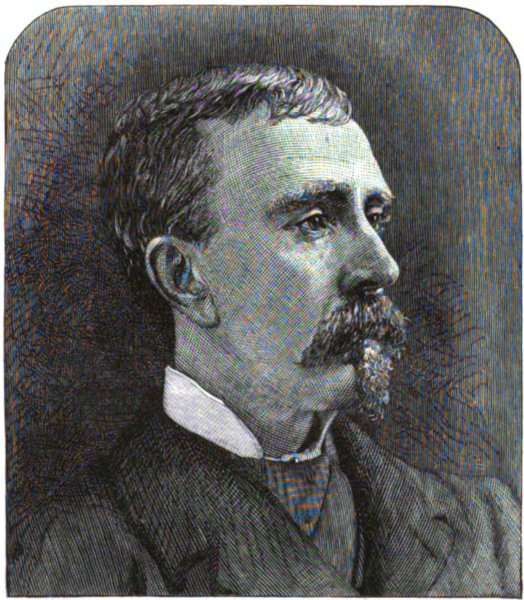
William B Somerville. The Telegraph in America, James D. Reid
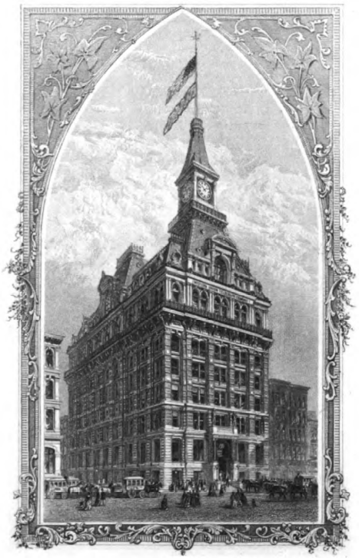
Western Union Telegraph Building 195 Broadway, New York, built 1872
Previous location, where William Somerville worked, was 145 Broadway.

Obituary from New York Daily Tribune, Monday, 26 April 1897:
William B Somerville, Superintendent of the press service of the Western Union Telegraph Company, whose death on Saturday was briefly announced in yesterday’s Tribune, was born in Toronto fifty seven years ago. He came to this country at an early age and thirty years ago entered the employ of the Western Union, in which he gradually rose to the responsible place he held at his death. He was greatly respected by the employees and officers of the company, and his death is sincerely regretted.
Upwards of a score of his old business associates called at Mr Somerville’s home, Amsterdam Ave and one hundred and fifty fifth street yesterday to offer their condolence to Mrs Somerville.
Mr Somerville served during the war, and soon after its close, married, his wife’s former name having been Mrs Buckner. He leaves no children, but, besides Mrs Somerville, several stepchildren and two sisters survive him.
He had been ill sixteen weeks, bladder trouble, which made necessary an operation, performed a week ago, being the cause of death. The funeral will be held at the house this afternoon and the burial will be at Cleveland, where his father, mother and three sisters are buried and where one of his surviving sisters lives.

